Level 2

Samkary Paramga

for learn basic python

Lesson1

Operators part2

Introduction and remember:

Operators: are used to perform operations on variables and values.

Like:

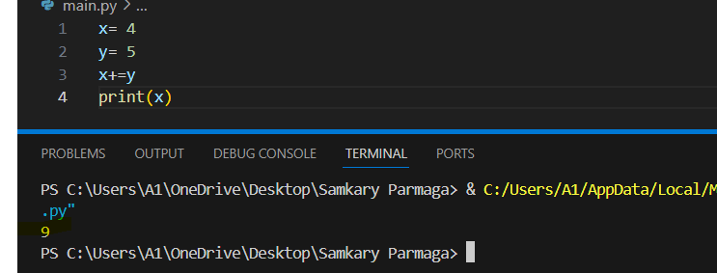

In lesson1 in level 2 we will learn a comparison and logic. It is a fun for learn mains or basics of programming let is start.

1. Comparison: are used to compare two values like: [==,!=,<,>,<=,>=]

|  |  |
| --- | --- |
| **operators** | **define** |
| **==** | (Equal): Checks if two operands are  equal or not. |
| **!=** | (not equal): Checks if two operands are  equal or not, If the values are  not equal, then the condition  becomes true, |
| **<** | Less than |
| **>** | Greater than |
|  |  |
| **>=** | Greater than or equal to |
| **<=** | Less than or equal to |

Example:

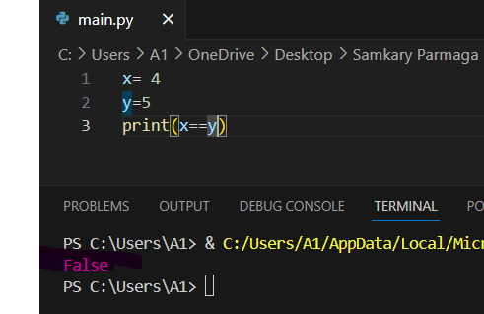 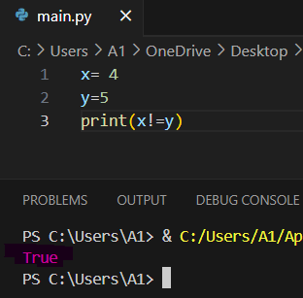

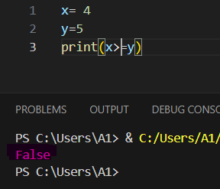 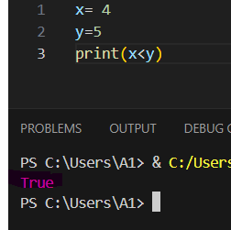

1. **Logic**: used to combine conditional statements, allowing you to perform operations based on multiple conditions like[and, or, not].

|  |  |
| --- | --- |
| Operators | defination |
| and | Returns True if both statements are true |
| or | |  | | --- | | Returns True if one of the statements is true | |
| not | Reverse the result, returns False if the result is true |

Example:

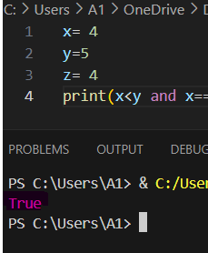 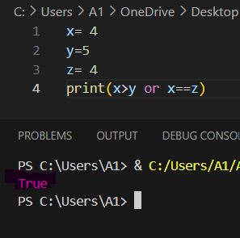

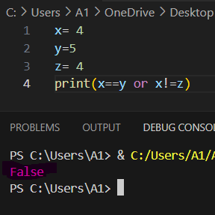 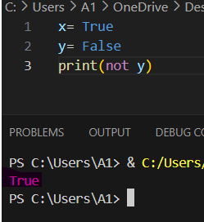

Finish the lesson!….

Lesson2

String methods in python

Introduction:

String in every programming languages have a different types.

Today you will studying String methods in python. Python has a set of built-in methods that you can use on strings.

1. Upper(): method returns a string where all characters are in upper case.

Example:

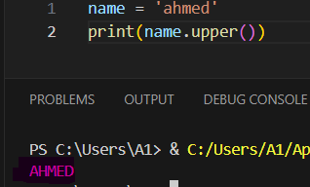

1. Lower(): method Converts a string into lower case.

Example:

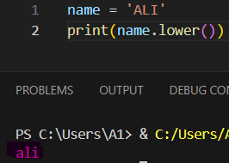

1. Capitalize(): Converts the first character to upper case.

Example:

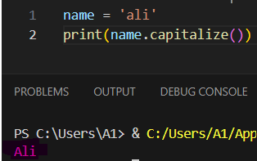

1. strip(): method removes any white space from the beginning or the end.

Example:

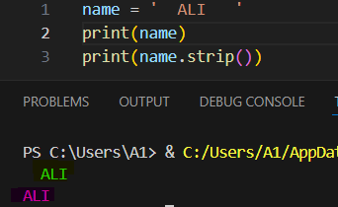

1. Len(): It is a method used to measure the length of a text or To find out the number of letters in the text.

Note: You can count the number of spaces in the text.

Example:

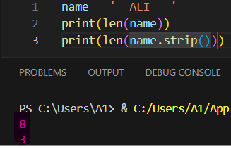

1. Replace(): method replaces a string with another string.

Example:

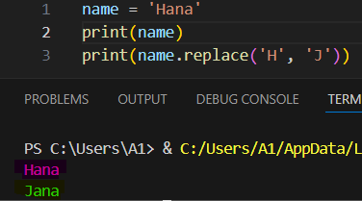

1. Index(): Searches the string for a specific value and returns the position where it was found.

Note: Index starts search at 0

Example:

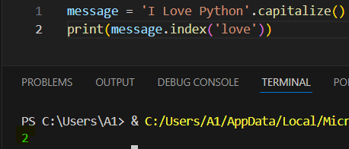

1. Find(): Searches the string for a specific value and returns the position where it was found.

**Sytnax:**

string.find(value, start, end)

Note: The find() method is almost the same as the index() method, the only difference is that the index() method raises an exception if the value is not found.

Note: The find() method returns -1 if the value is not found.

Example:

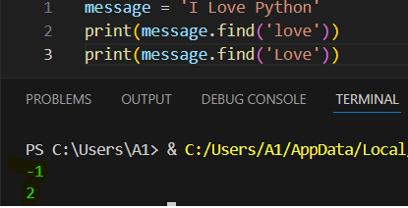

1. Extras:

* Slicing: can return a range of characters by using the slice syntax.

Note: Specify the start index and the end index, separated by a colon, to return a part of the string.

Example:

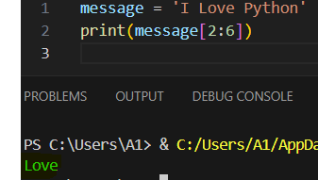

* **Comments**: are ignored the code by interpreter and used to explain Python code.

Comment there are two types: single line comment and, multi line comments.

In a single line comment use # , in a multi line comments use ‘’’

Example:

 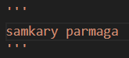

Finish the lesson !!!…

Lesson 3

Conditions

Introduction:

There is no website or application that has conditions. Every application must have conditions and orders. For example, the login page. How does it check that you have logged in or purchased a product and stored it in the shopping cart? These are the conditions.

* **Conditions**: Control the flow of code execution based on conditions and allow you to control the flow of your program based on whether certain conditions are true or false.

These conditions can be used in several ways, most commonly in "if statements" and loops.

The condition statement include on the (if, elif, else)

1. **If:** is used to execute a block of code, only if the condition specified holds true.

Syntax:

if condition:

Exect code

Note: you must important indentation

Like:

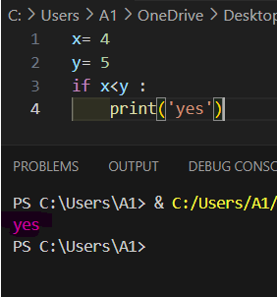

indentation

1. **Elif:** is used for multiple condition checking in an if statement and like the if syntax .

**Like:**

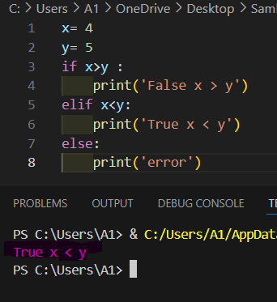

1. **Else:** is used to execute a block of code if the same condition is false.

Like:

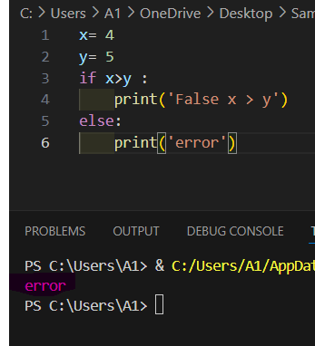

Exercise: Create two variables, one with a value of 10 and the other with a value of 5. Use the conditions to check.

* If the value of the first variable is greater than the second, print yes.
* If the value of the second variable is greater than the first, print no.
* If not, print none.

Finish the lesson!…

Lesson4

Short hand if condition and nested if

Remember:

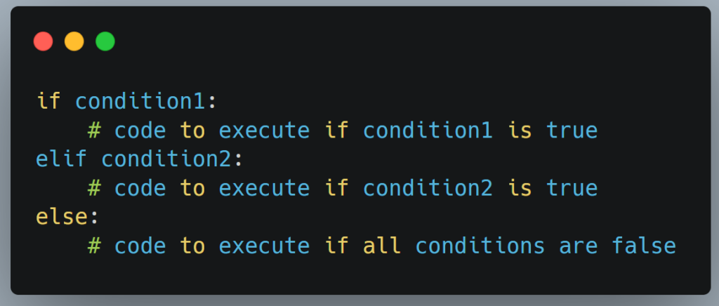

Introduction:

In this lesson we will learn how to write an if and else condition in one line. The subject is very easy and simple, and it will also teach you a new way of writing. We will also study how to do several things using an if condition.

1. **Shorthand (if, else..):** If you have only one statement to execute, one for if, and one for else, you can put it all on the same line.

Syntax:

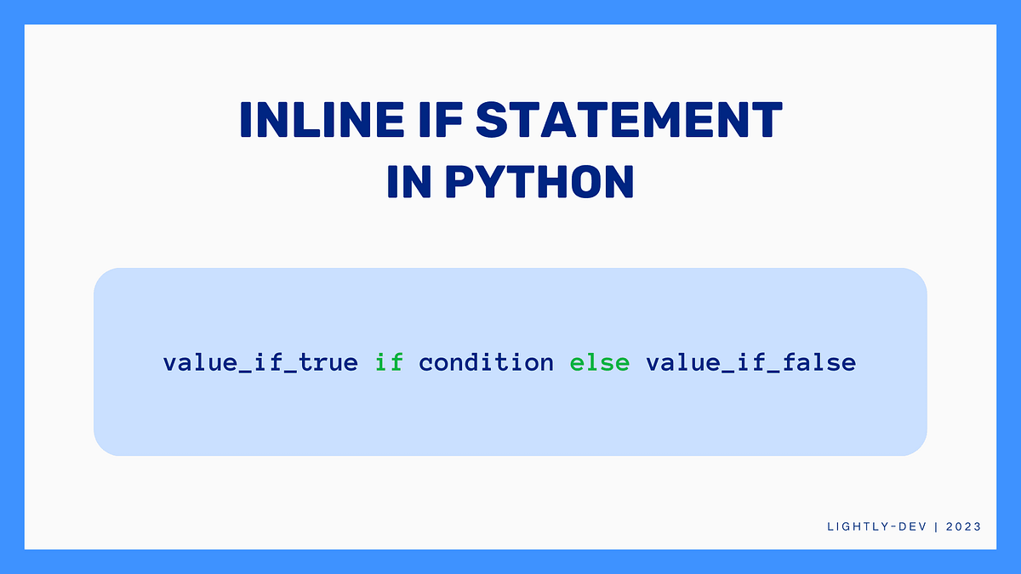

Example:

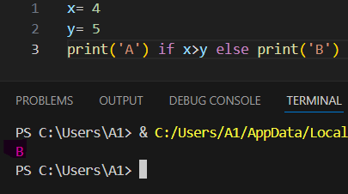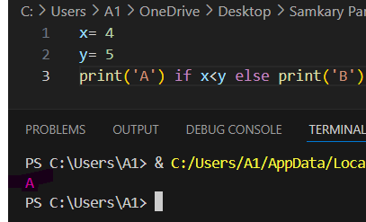

Advanced example:

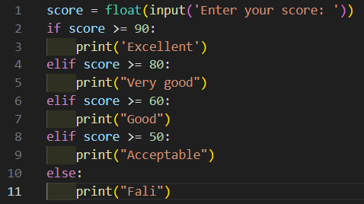

Explane:

1. An input was created that takes the number from the user and converts it to a float and stores it in a variable called (Score).
2. Then the program analyzes the value. If it is greater than or equal to 90, it prints “Excellent.” If it is greater than or equal to 80, it prints “Very good.” If it is greater than or equal to 60, it prints “Good.” If it is greater than or equal to 50, it prints “Acceptable.”
3. If it disobeys conditions, it will print “fail”
4. Nested if:-

You can have if statements inside if statements, this is called nested if statements.

Imagine that you are an employee at the airport and you ask the passengers if they have their passports. If they do, you ask them which country they are from. If they are from Egypt, they say, “Good, welcome to Egypt.” If they are from another country, they ask them which country they live in and then they say, “Come in, welcome to Egypt.”

This is nested if that perform multiple actions.

Example:

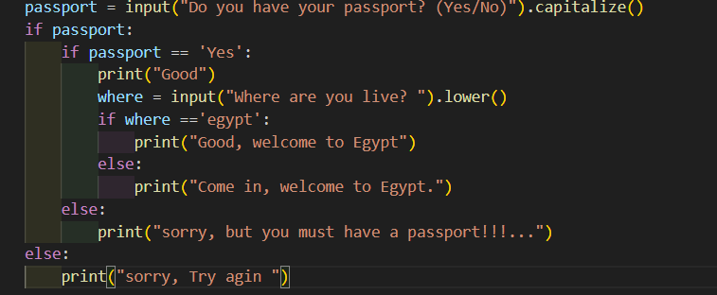

Finish the lesson!!!…

Lesson 5

Project level2

This is final level: you require to create this is project: -

You are required to implement a program that calculates even and odd numbers by having the user input an integer value.

The program also checks if the number is equal to 0 and prints: The number you entered is neither even nor odd.

Like:







Finish the level2 !!!…